EXPERIMENT 3.11

setwd("\\Users\\noelm\\Desktop\\Saadhangal\\STUDY STEFF\\RSET\\CLASSES\\S2\\RP LAB\\Codes")

dataf<-read.csv("emp.csv")

dataf

print(is.data.frame(dataf))

print(ncol(dataf))

print(nrow(dataf))

print(max(dataf$salary))

r<-subset(dataf, salary == max(salary))

print(r)

q<-subset(dataf,dept=="IT")

print(q)

t<-subset(dataf,as.Date(start_date)>as.Date("2014-01-01"))

print(t)

write.csv(t,"output.csv")

newdataf<-read.csv("output.csv")

newdataf

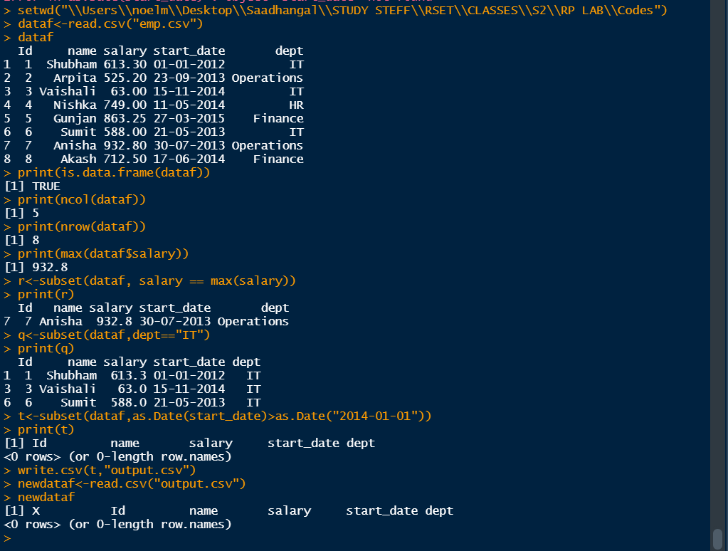

EXPERIMENT 4.1

library(ggplot2)

ggplot(iris,aes(x=Petal.Length,y=Petal.Width))+

geom_point(aes(color=factor(Species)))+

geom_smooth(method="lm")+

geom_label(aes(label=Species,hjust=0),nudge_y=0.5,size=2)

print(iris)

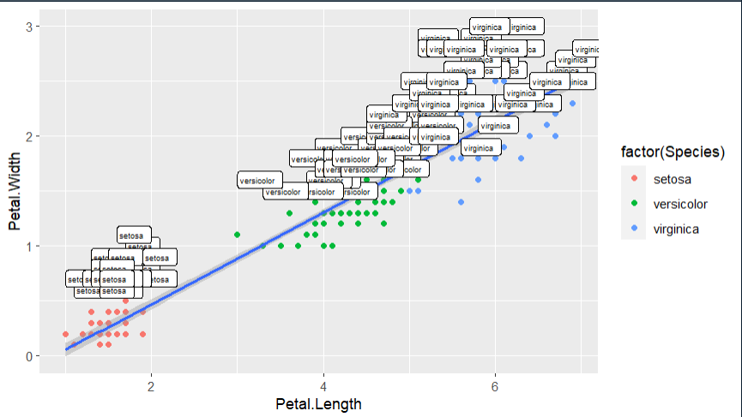

EXPERIMENT 4.2

library(ggplot2)

ggplot(diamonds, aes(x=price))+geom_histogram(aes(color="red", fill="green"))

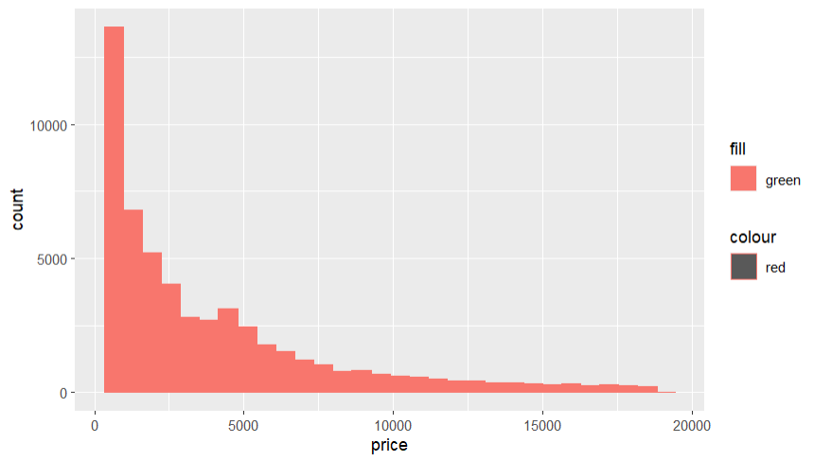

EXPERIMENT 4.3

library(ggplot2)

ggplot(diamonds, aes(x=price)) + geom_histogram(color="green", fill="blue")

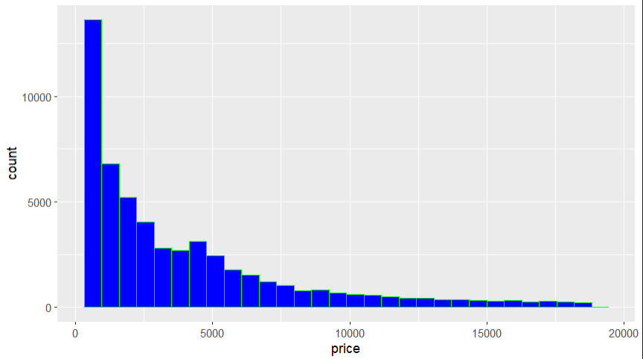

EXPERIMENT 4.4

library(ggplot2)

ggplot(diamonds, aes(cut))+geom_bar(aes(color="yellow"))

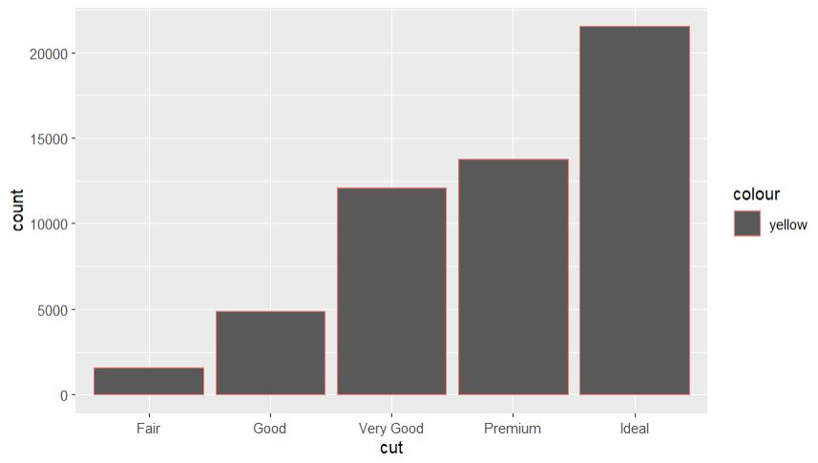

EXPERIMENT 5.1

setwd("\\Users\\noelm\\Desktop\\Saadhangal\\STUDY STEFF\\RSET\\CLASSES\\S2\\RP LAB\\Codes")

dataset=read.csv("tvmarketing.csv", header=T, colClasses = c("character", "character"))

simple.fit = lm(TV~Sales, data=dataset)

summary(simple.fit)

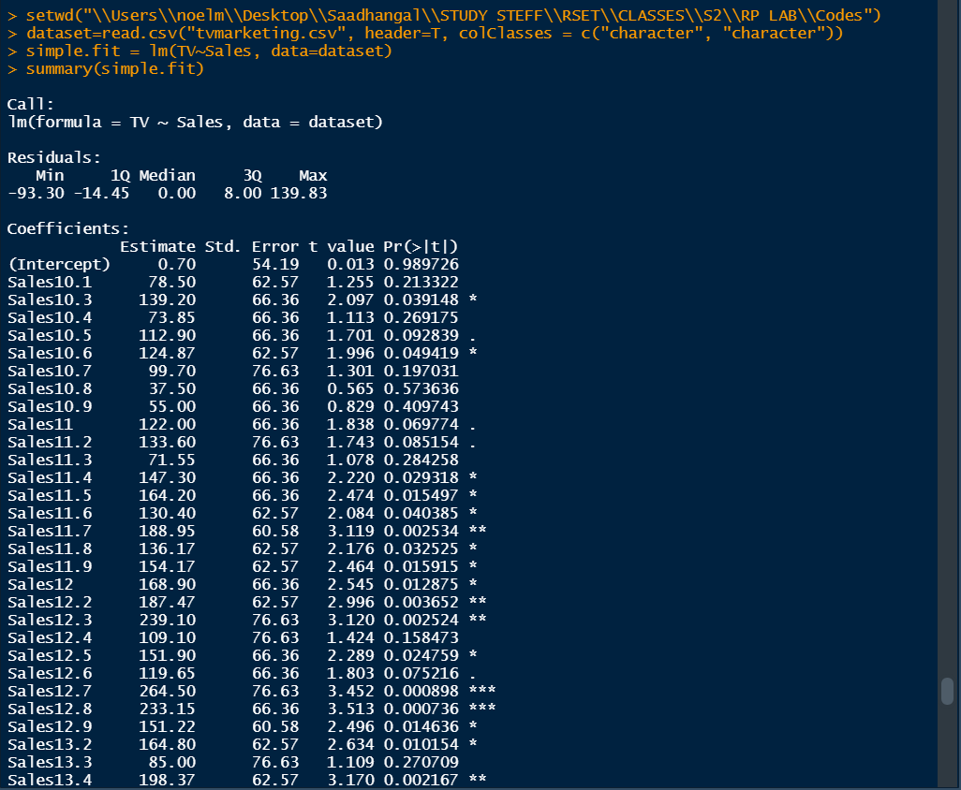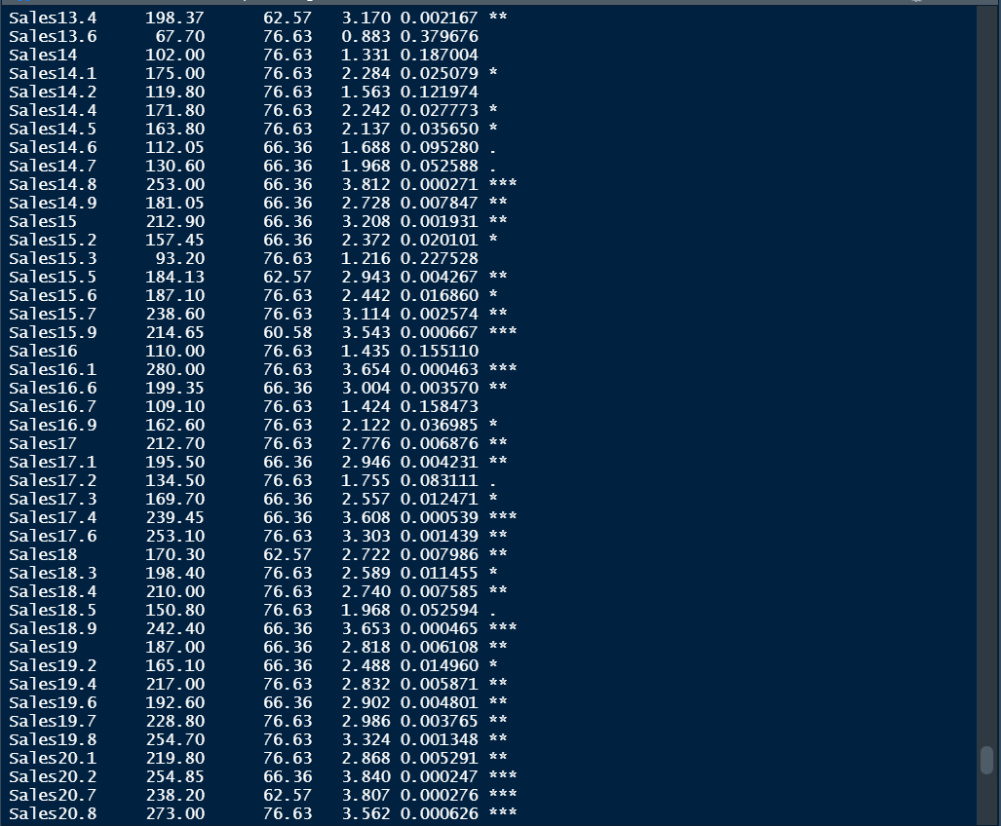

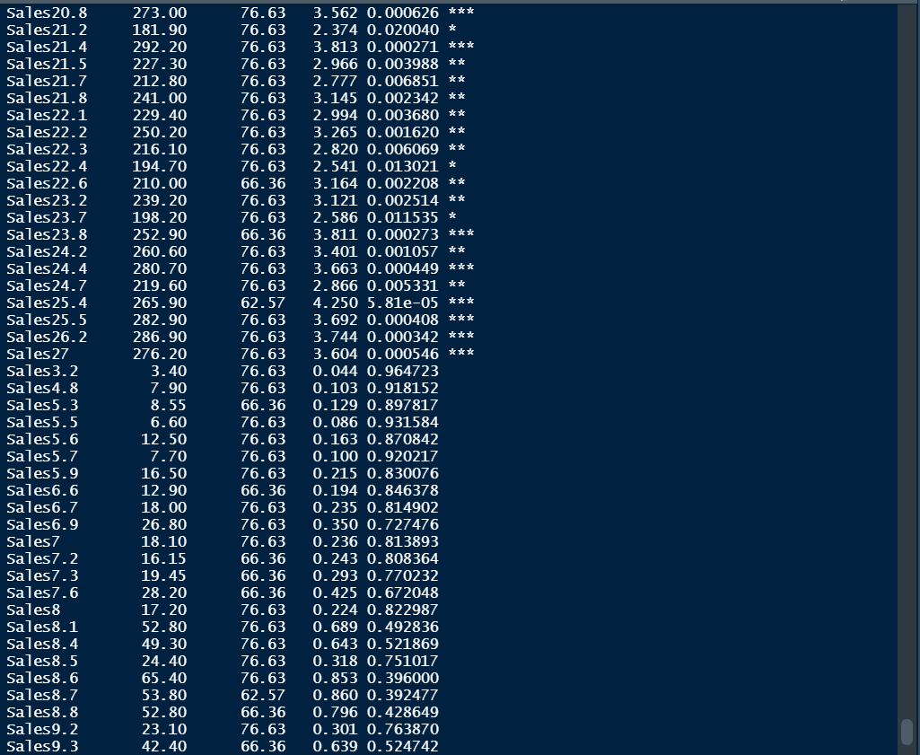

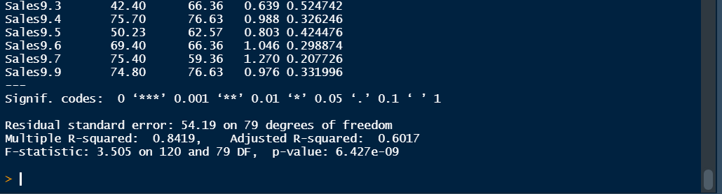

EXPERIMENT 5.2

setwd("\\Users\\noelm\\Desktop\\Saadhangal\\STUDY STEFF\\RSET\\CLASSES\\S2\\RP LAB\\Codes")

getwd()

dataset=read.csv("jobprof.csv", header=T, colClasses = c("character"))

multi.fit = lm(y~x1+x2+x3,data=dataset)

summary(multi.fit)

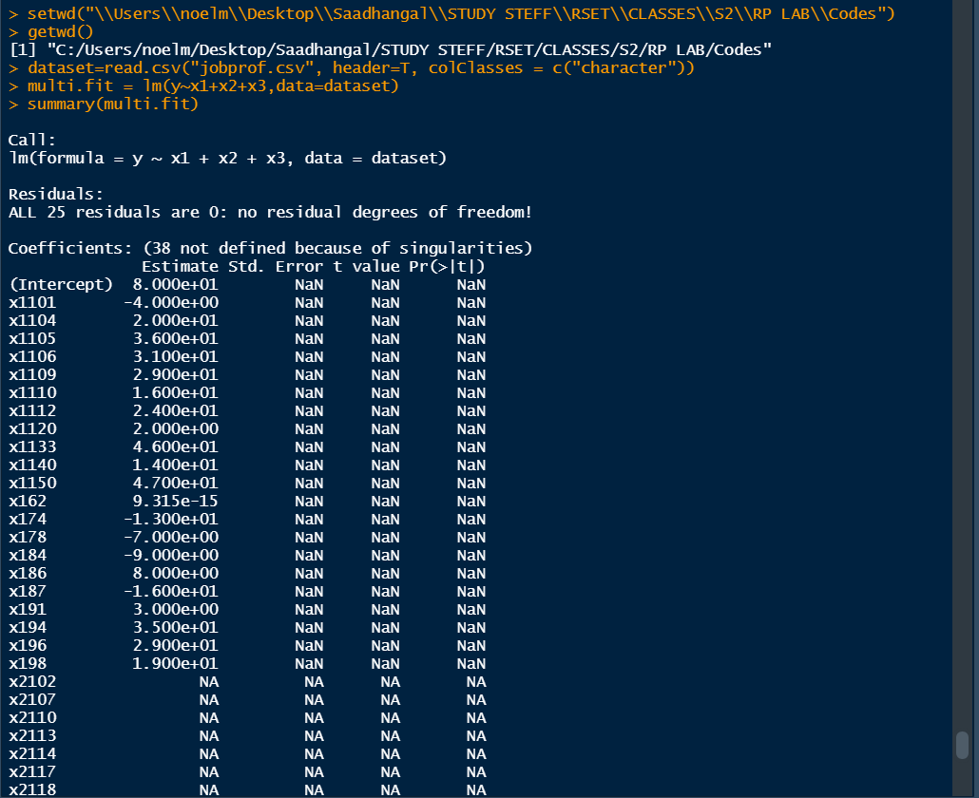

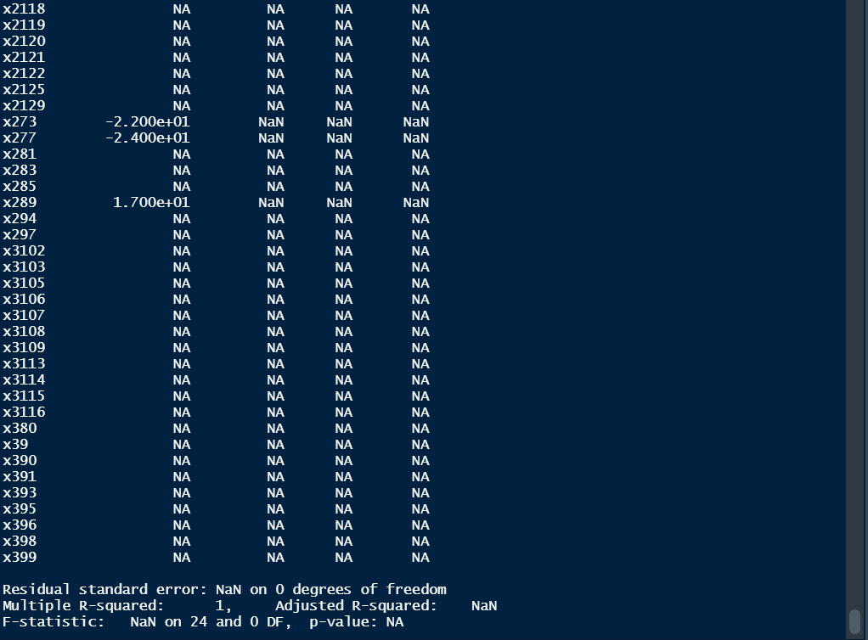

EXPERIMENT 1.6

prime<-function(num)

{

for (i in 1:num)

{

flag=0

for(j in 2:(i/2))

{

if(i%%j==0)

{

flag=flag+1

}

}

if(flag==0)

{

print(i)

}

}

}

print("The prime numbers till 50 are: ")

print=prime(50)

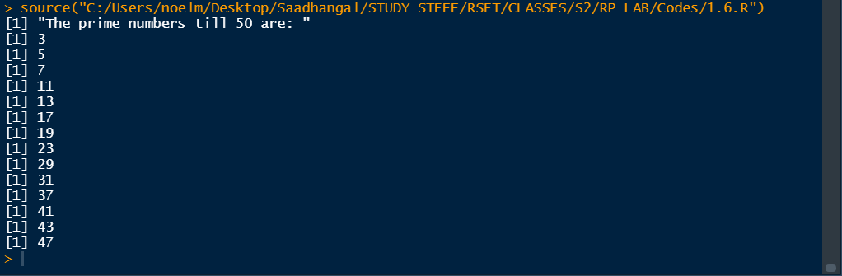

EXPERIMENT 1.7

factors<-function(n)

{

  cat("\nThe factors of 100 are \n")

  for(i in 1:n)

  {

    if(n%%i==0)

    {

      print(i)

    }

  }

}

print=factors(100)

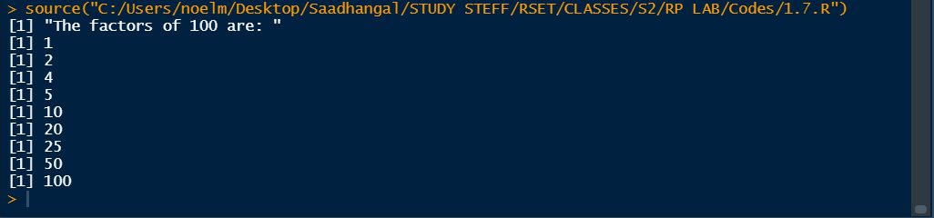

EXPERIMENT 1.9

odate<-as.Date("2022-08-18")

print("Current date is")

print(odate)

n=5

adate=odate+n

sdate=odate-n

print(adate)

print(sdate)

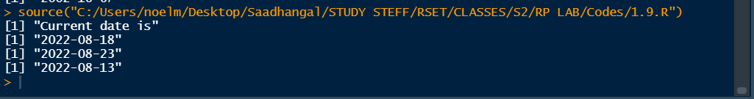

EXPERIMENT 1.10

date1<-as.Date("2022-08-18")

date2<-as.Date("2003-05-14")

print(date1)

print(date2)

print(difftime(date1, date2, unit="days"))

